**Cairo University**

**Faculty of Computers and Artificial Intelligence**

**Department of Computer Science**

**PetYard**

Implemented by

|  |  |
| --- | --- |
| 20206056 | Lo’ai Osama Mohammed |
| 20206046 | Omar Mahmoud Salah |
| 20206067 | Mohamed Hamdy Sayed |
| 20206088 | Yahia Walid Samir El Alfy |
| 20206098 | Youssef Mahmoud Abd El Fatah |

Graduation Project

Academic Year 2023-2024

Midyear Short Documentation

Supervised by

*Dr. Lamiaa AboZaid*

Project Short Documentation

1. **Abstract:**

Our project focuses on addressing the challenges present within the pet care service industry, particularly in Egypt, where there is a lack of applications connecting pet owners with reliable and convenient pet care service providers. After noticing this gap, we decided to develop our application and fill this gap by providing the services that a lot of pet owners need, which are pet walking, sitting, and boarding to name a few.

To implement this solution, we plan to utilize modern mobile development technologies, including Flutter for the frontend, Node.js for the backend, and PostgreSQL as the relational database management system. With Flutter, we aim to create a seamless and visually appealing user interface, providing an intuitive experience for both pet owners and service providers. For the backend infrastructure, we will leverage the robustness and scalability of Node.js along with Express.js to handle server-side logic and API endpoints effectively. Additionally, we will integrate PostgreSQL to securely store user data, service listings, and booking information, ensuring data integrity and confidentiality.

Furthermore, our application will prioritize the safety and well-being of pets by implementing stringent vetting processes for service providers and facilitating transparent communication between pet owners and service providers. Our platform will aim to build a community of trusted service providers who are committed to providing top-notch care for pets. Additionally, we will incorporate features such as real-time updates on pet activities, GPS tracking during walks, and secure payment processing to enhance the overall user experience and ensure peace of mind for pet owners. By leveraging these advanced technologies and implementing user-centric features, we aspire to revolutionize the pet care service industry in Egypt and provide a comprehensive solution that caters to the needs of both pet owners and service providers.

1. **Introduction:**

In the current pet care service industry, there is a lack of centralized platforms that effectively connect pet owners with reliable and convenient pet care service providers especially in Egypt. Pet owners often struggle to find trustworthy and suitable service providers for their pets' needs, such as pet sitting, walking, grooming, and boarding. On the other hand, pet care service providers face challenges in reaching potential clients, managing bookings efficiently, and establishing a reputable presence in the market.

As animal lovers, we understand the importance of ensuring the well-being and happiness of pets. we are motivated to solve this problem to create a solution that simplifies the process of finding and booking quality pet care services. By providing a centralized platform that connects pet owners with trusted service providers, we aim to alleviate the stress and uncertainty associated with pet care arrangements. Our goal is to facilitate seamless and enjoyable experiences for both pet owners and service providers.

1. **Background:**

The pet care service industry has experienced notable growth in recent years, driven by increasing pet ownership and the demand for professional care services. However, this growth has highlighted challenges in connecting pet owners with reliable service providers, particularly in regions like Egypt.

To address these challenges, platforms like Rover and PetBacker have emerged, offering platforms for pet owners to find and book care services.

Despite the availability of existing platforms, there remains a gap in localized solutions for pet care services in Egypt. Our app aims to fill this gap by providing a user-friendly platform tailored to the needs of pet owners and service providers in the region.

Our application serves two main beneficiaries: pet owners and service providers. Pet owners rely on our platform to easily find, and book trusted pet care services. On the other hand, service providers benefit from increased visibility and access to a larger customer base.

**Pet Owners:** They benefit from a centralized platform simplifying the process of finding and booking quality pet care services. Access to reliable service providers instils confidence in their pet care arrangements, ensuring peace of mind and informed decision-making.

**Pet Care Service Providers:** Our platform offers service providers access to a broader customer base, facilitating business growth. Streamlined booking processes and improved communication help manage bookings efficiently, enhancing their market presence and reputation.

1. **Problem definition:**

The problem at hand revolves around the inefficiencies and challenges faced within the pet care service industry. Despite the increasing demand for professional pet care services, there exists a significant gap in the market: the lack of a centralized platform that effectively connects pet owners with reliable and convenient service providers.

Due to this gap, pet owners struggle with taking care of their pets when they are busy with work or other commitments, and their pets are left without the proper care they need. Pet care service providers also struggle in efficiently finding and connecting with pet owners that need their services.

1. **Related work:**

Similar work to our application includes platforms like Rover, Pet Backer, Trusted House Sitters, and Egy puppy, which aim to connect pet owners with reliable pet care services. These platforms offer features such as pet sitting, walking, and boarding, along with user reviews. However, our application distinguishes itself by focusing specifically on the Egyptian market, providing localized solutions tailored to the unique needs of pet owners and service providers in Egypt. We prioritize features such as stringent vetting processes for service providers, and real-time updates on pet activities to ensure a seamless and reliable experience for users.

|  |  |  |  |  |  |
| --- | --- | --- | --- | --- | --- |
|  | **Pet Backer**  **(web site and app)** | **Rover**  **(web site)** | **Trusted house sitters**  **(website)** | **Egy puppy**  **(website)** | **Pet yard (App)** |
| Grooming |  | **X** | **X** |  |  |
| Sitting |  |  |  | **X** |  |
| Boarding |  |  |  | **X** |  |
| Pet Walking |  |  | **X** | **X** |  |
| Day care |  |  | **X** | **X** | **X** |
| Pet taxi |  | **X** | **X** | **X** | **X** |
| Selling goods | **X** | **X** | **X** |  |  |
| Drop-in visits |  |  | **X** | **X** | **X** |
| Health care | **X** | **X** | **X** |  |  |

1. **Project Specifications:**

After careful consideration, we found the best tools that suit our project which are:

**Flutter for Frontend Development:** We utilize Flutter, a cross-platform framework, to create a seamless and visually appealing user interface.

**Node.js for Backend Development:** Node.js is employed for building robust backend infrastructure, handling server-side logic effectively.

**PostgreSQL for Database Management:** PostgreSQL serves as the relational database management system, securely storing user data and other essential information.

**6.1 System Architecture:**

**6.2 Stakeholders:**

Stakeholders for our application can be categorized into internal and external groups, each playing a crucial role in its success.

**Internal Stakeholders:**

Development Team: The team responsible for designing, developing, and maintaining the application, including software engineers, designers, and project managers.

**External Stakeholders:**

Pet Owners: External users who utilize the application to find and book pet care services for their pets. They rely on the platform to connect with trusted service providers and ensure the well-being of their pets.

Pet Care Service Providers: External users offering pet care services such as pet sitting, walking, grooming, and boarding. They depend on the platform to reach potential clients, manage bookings efficiently, and grow their businesses.

**6.3 Functional Requirements:**

In the Functional Requirements segment, we wrote all the functional requirements of our system, inside each requirement there’s a description section to explain the requirement, a priority section that has one of three values (low – medium – high), and finally the acceptance criteria for each requirement.

Each requirement is explained from two sides; Pet owner side and Service provider side, to show how the system works from both perspectives.

**Requirement 1: User Authentication**

**Pet Owner side:**

* **Description:** Pet Owner makes a new account and fills in the necessary information which is username, email, password, and phone number, then fills at least one pet profile.
* **Priority:** High.
* **Acceptance Criteria:** Pet Owner can successfully register, log in, and access the services provided.

**Service Provider side:**

* **Description:** Service provider makes a new account and fills in the necessary information which is username, email, and password, then selects the service(s) they want to provide.
* **Priority:** High.
* **Acceptance Criteria:** Service Provider can successfully register, log in, and start providing their service.

**Requirement 2: making pet profile**

* **Description:** Upon logging in for the first time, pet owner must make one or more profiles for their pet(s) by filling in the necessary information which includes pet weight, age, breed, and gender.
* **Priority:** High.
* **Acceptance Criteria:** Pet owner filled in the information, and pet profile is successfully made.

**Requirement 3: Service browsing and Selection**

* **Description:** Pet owners can choose the service they want and filter the carers by name, clinic/individual, ratings, and location.
* **Priority:** High.
* **Acceptance criteria:** Pet owners can successfully browse and select the service they desire.

**Requirement 4: pet grooming service**

**Pet Owner side:**

* **Description:** Pet owner selected a specific clinic/individual and specifies the type of grooming they want and can now book the available time slots for a set price.
* **Priority:** High.
* **Acceptance criteria:** Pet owner can choose grooming options, such as bath, haircut, or nail trimming, and schedule appointments accordingly.

**Service Provider side:**

* **Description:** Service providers can specify the type of grooming they’ll provide and put the available time slots that they will work in.
* **Priority:** High.
* **Acceptance criteria:** Service providers can successfully add time slots to their work schedule.

**Requirement 5: Pet Sitting Service**

**Pet Owner side:**

* **Description:** Pet owner can submit pet sitting service requests, including their location, start and end times, and await responses from Service providers.
* **Priority:** High.
* **Acceptance criteria:** 
  + Pet owner can enter details such as location, start time, and end time for the pet sitting request.
  + The request is made available for Service providers to engage with.

**Service Provider side:**

* **Description:** Service providers can view pet owner requests and choose to connect with the pet owner to offer their services.
* **Priority:** High.
* **Acceptance criteria:** 
  + Service providers can see the requests made by users.
  + Service providers can show their interest in offering this service to the users.

**Requirement 6: Pet Walking Service**

**Pet owner side:**

* **Description:** Pet owner can request pet walking services by specifying their starting location, preferred start and end times, and providing a preferred route for the Service provider to take.
* **Priority:** High.
* **Acceptance criteria:**
  + Pet owner can input their starting location for the pet walk.
  + Pet owner specifies the preferred start and end times for the pet walking service.
  + Pet owner can provide a preferred route.
  + Service providers can engage with the request.

**Service provider side:**

* **Description:** Service provider can connect with a pet owner through a request.
* **Priority:** High.
* **Acceptance criteria:**
  + Service providers receive detailed information about the requested pet walking service, including location, timing, and preferred route.
  + Service providers can view pet walking service requests.
  + Service providers can show their interest in offering this service to the pet owners.

**Requirement 7: Boarding Service Booking**

**Pet owner side:**

* **Description:** Pet owner can select a Service provider for boarding services, view the available time slots offered by the selected carer, and book the chosen provider for a specified start and end date.
* **Priority:** High.
* **Acceptance criteria:** 
  + Upon selecting a service provider, the system displays the available time slots for boarding services offered by the chosen provider.
  + Pet owner can select the start and end date for the boarding service from the available time slots.
  + The system confirms the booking, notifying both the pet owner and the selected Service provider.

**Service provider side:**

* **Description:** Service providers can view and choose to accept the incoming requests they are getting.
* **Priority:** High.
* **Acceptance criteria:** 
  + Service providers can view and accept the requests made by pet owners.
  + The system confirms the booking, notifying both the pet owner and the selected Service provider.

**Requirement 8: Reservation management**

**Pet owner side:**

* **Description:** The system should provide robust reservation management capabilities to enable pet owners and Service providers to view, modify, and cancel reservations.
* **Priority:** High.
* **Acceptance criteria:** 
  + Pet owner can view a list of their upcoming and past reservations.
  + Pet owner can modify reservation details such as dates, times, or services before with modification policies communicated.
  + Pet owner can cancel reservations, with appropriate notifications and cancellation policies communicated.

**Service provider side:**

* **Description:** The system should provide robust reservation management capabilities to enable pet owners and service providers to view, modify, and cancel reservations.
* **Priority:** High.
* **Acceptance criteria:** 
  + Pet care providers can access a dashboard displaying upcoming reservations.
  + Service providers can cancel reservation, with appropriate notifications and cancellation policies communicated.
  + Service providers receive notifications of reservation modifications or cancellations.

**Requirement 9: Online Store for Pet Accessories and Food**

**Pet owner side:**

* **Description:** The system should include an online store feature that allows users to browse, search, and purchase pet accessories and food.
* **Priority:** Low.
* **Acceptance criteria:**
  + **Product Catalog:**
    - The system displays a catalog of pet accessories and food items.
    - Pet owners can filter and search for products based on categories, brands, and other relevant criteria.
  + **Product Details:**
    - Pet owners can view detailed information for each product, including images, descriptions, prices, and customer reviews.
  + **Shopping Cart:**
    - Pet owners can add products to their shopping cart.
    - The system updates the shopping cart in real-time, displaying the total cost.
  + **Checkout Process:**
    - Pet owners can proceed to checkout, providing shipping information and selecting payment options.
    - The system securely processes payments and sends order confirmations to users.
  + **Order History:**
    - Pet owners can view their order history, including past purchases and order statuses.

**Service provider side:**

* **Description:** Application should allow the service provider to display add their products on the Online store.
* **Priority:** Low.
* **Acceptance criteria:** Service provider can successfully offer their products and pet owners can purchase them.

**Requirement 10: Health Care Appointment Booking**

**Pet owner side:**

* **Description:** The system should allow pet owners to book appointments with clinics for health check-ups and vaccinations based on available time slots.
* **Priority:** High.
* **Acceptance criteria:**
  + Pet owner can select a clinic and view the available time slots for appointments.
  + Pet owner can choose a preferred time slot and book an appointment for health check-up or vaccination.

**Service provider side:**

* **Description:** Clinics should have the capability to set their working time slots for the pet owners to reserve.
* **Priority:** High.
* **Acceptance criteria:** Clinics can successfully set their working time slots and these time slots should be reservable by the pet owners.

**Requirement 11: User Reviews and Ratings**

* **Description:** Pet owners can leave reviews and ratings for the following services provided by the application in requirements: 4 (Grooming), 5 (Pet sitting), 6 (Pet walking), 7 (Boarding), 10 (health care).
* **Priority:** Medium.
* **Acceptance criteria:** Pet owners can submit reviews, and the average rating is displayed for each service provider.

**6.3 Non-Functional Requirements:**

**Requirement 1: Performance**

**1.1 Response time:**

Application should have an average response time of no more than 2 seconds for user interactions.

**1.2 Throughput:**

Application should support 100 to 1000 requests per second.

**1.3 Scalability:**

Application should be able to handle a minimum of 1000 concurrent users without noticeable drop in performance.

**1.4 Reliability:**

Recovery time should be 15 to 30 minutes for common failures.

**Requirement 2: Usability**

**2.1 User interface:**

The mobile app is designed to be easy to use, providing a great experience for users. With a focus on intuitive design and smooth navigation, interacting with the app feels effortless, every detail is carefully crafted to ensure users enjoy using the app every time.

**Requirement 3: Security**

**3.1 Authentication:**

User authentication must be secure and support multi-factor authentication by using phone number or email for user accounts to ensure safety.

**3.2 Authorization:**

Access to different services and features must be controlled based on user roles to ensure that each user has access to the allowed services only.

**Requirement 4: Maintainability**

**4.1 Modularity:**

Modularity should be taken into consideration when building the system architecture, for ease in updates and additions to the code.

**4.2 Documentation:**

Comprehensive documentation is needed to ensure ease of future development.

**6.5 Class Diagram:**

**6.6 Sequence diagram:**

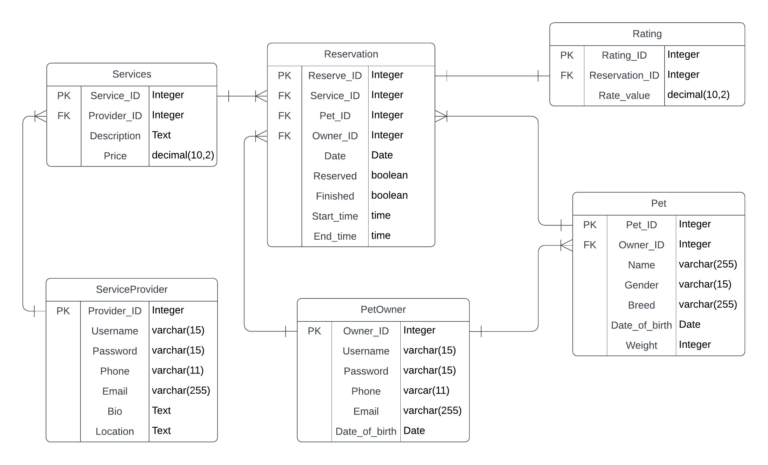**6.7 Entity Relationship Diagram:**

1. **Gantt Chart:**

